Comprehensive Digital Forensics & Incident Response Report
Incident Reference: INCD-2024-07-USB-LEAK
Incident Type: Insider Threat – Data Exfiltration via Removable Media
Date of Investigation: April 17, 2026
Prepared By: Ahmed Emad Nasr | Soc\IR Analyst

1. Executive Summary
On July 15, 2024, a confirmed insider threat incident resulted in the unauthorized access and exfiltration of sensitive payroll and Personally Identifiable Information (PII).
Forensic analysis of host-based artifacts confirms that a USB mass storage device was connected to the system, mounted, and actively used to browse a pre-staged directory structure. The threat actor accessed a targeted CSV file containing employee PII using a native Windows application (Notepad 64-bit).
The entire sequence—from device insertion to data access—was completed in under two minutes, indicating a deliberate and premeditated action rather than accidental user behavior.

2. Scope & Methodology
2.1 Scope
The investigation focused on reconstructing user activity and identifying evidence of data exfiltration through removable media using offline forensic artifacts.
2.2 Evidence Source
- Triage dataset: Payroll_leak_investigation
- No live system analysis was conducted
2.3 Tools Utilized
- Registry Explorer (Eric Zimmerman Tools)
Used to analyze SYSTEM registry hive for USB device artifacts
- ShellBags Explorer
Used to reconstruct user navigation history via UsrClass.dat
- JumpList Explorer
Used to identify file access activity through AutomaticDestinations

3. Detailed Artifact Analysis
3.1 USB Device First Connection
- Timestamp: 2024-07-15 03:36:22
- Artifact: SYSTEM Registry Hive
- Path: ControlSet001\Enum\USBSTOR
Analysis:
The Last Write Time of the USBSTOR subkey indicates the first successful installation and recognition of the USB device by the operating system.
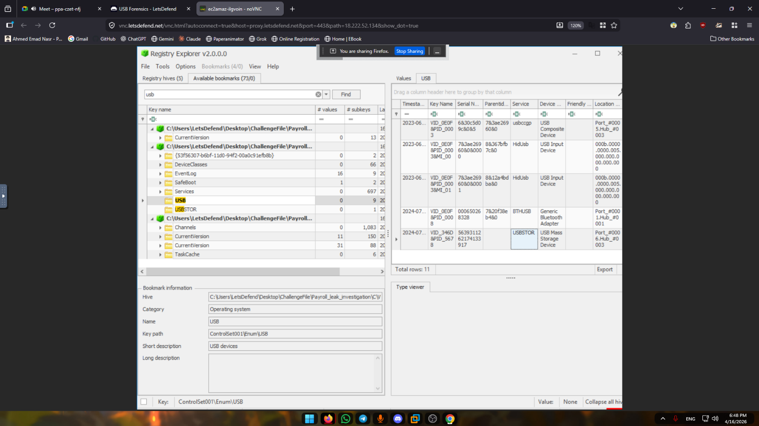

3.2 USB Device Serial Number
- Serial Number: 5639311262174133917
Analysis:
Extracted from the USBSTOR registry path, this uniquely identifies the physical USB device used in the incident.
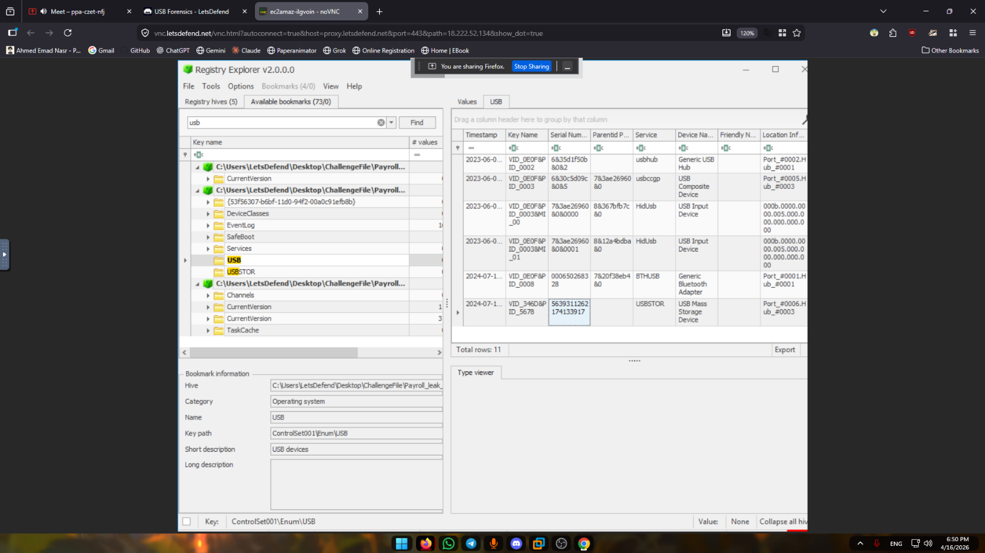

3.3 Assigned Drive Letter
- Drive Letter: E:
- Artifact: ShellBags (UsrClass.dat)
Analysis:
ShellBag entries confirm that the user actively accessed the removable drive via Windows Explorer, validating interaction beyond mere device insertion.
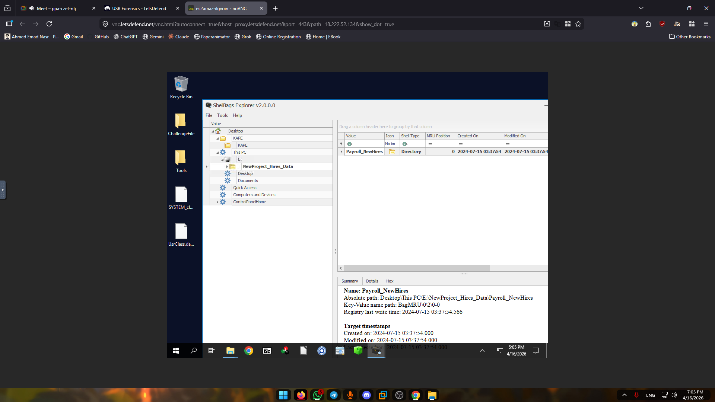

3.4 Staging Directory Identification
- Folder Name: NewProject_Hires_Data
- Artifact: ShellBags
Analysis:
The structured and descriptive folder name suggests intentional staging of data, indicating premeditated exfiltration activity.
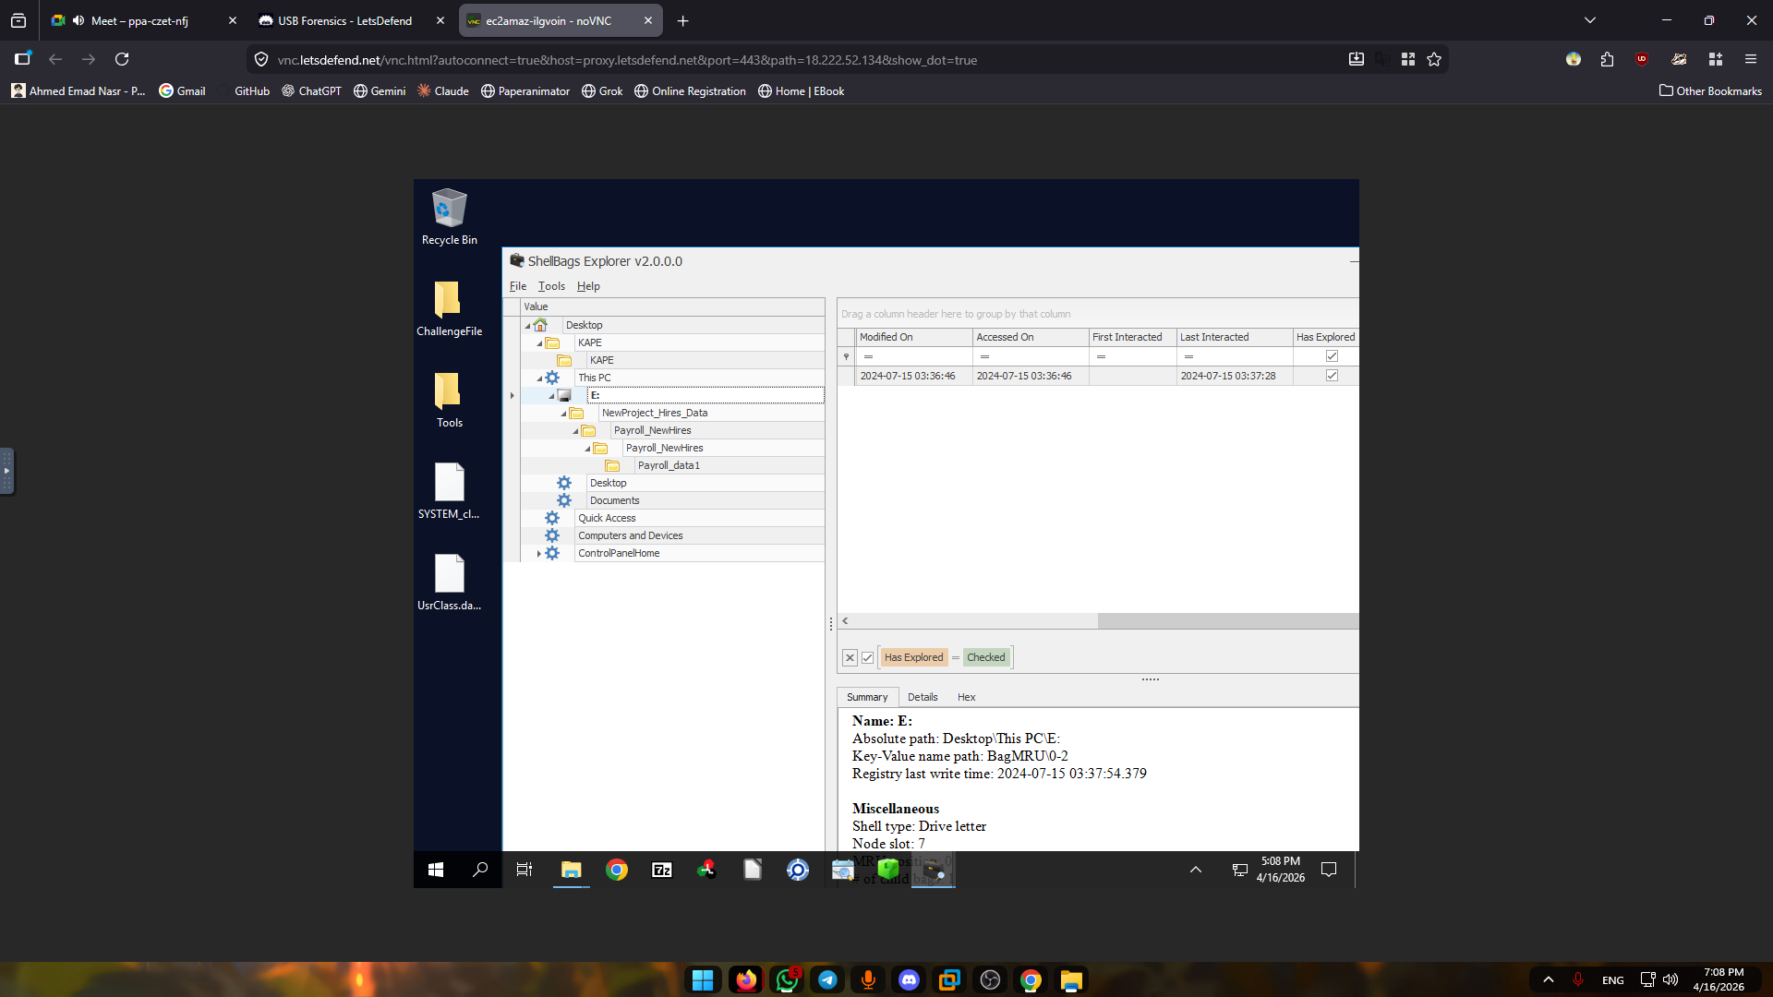

3.5 Folder Access Timestamp
- Timestamp: 2024-07-15 03:37:28
- Artifact: ShellBags
Analysis:
The "Last Interacted" timestamp confirms when the user navigated into the USB directory structure.

3.6 Application Used to Access Data
- Application: Notepad 64-bit
- Artifact: JumpLists (AutomaticDestinations)
Analysis:
JumpList analysis identifies the application used to open the file. The use of a native Windows tool aligns with Living-off-the-Land (LotL) techniques to avoid detection.
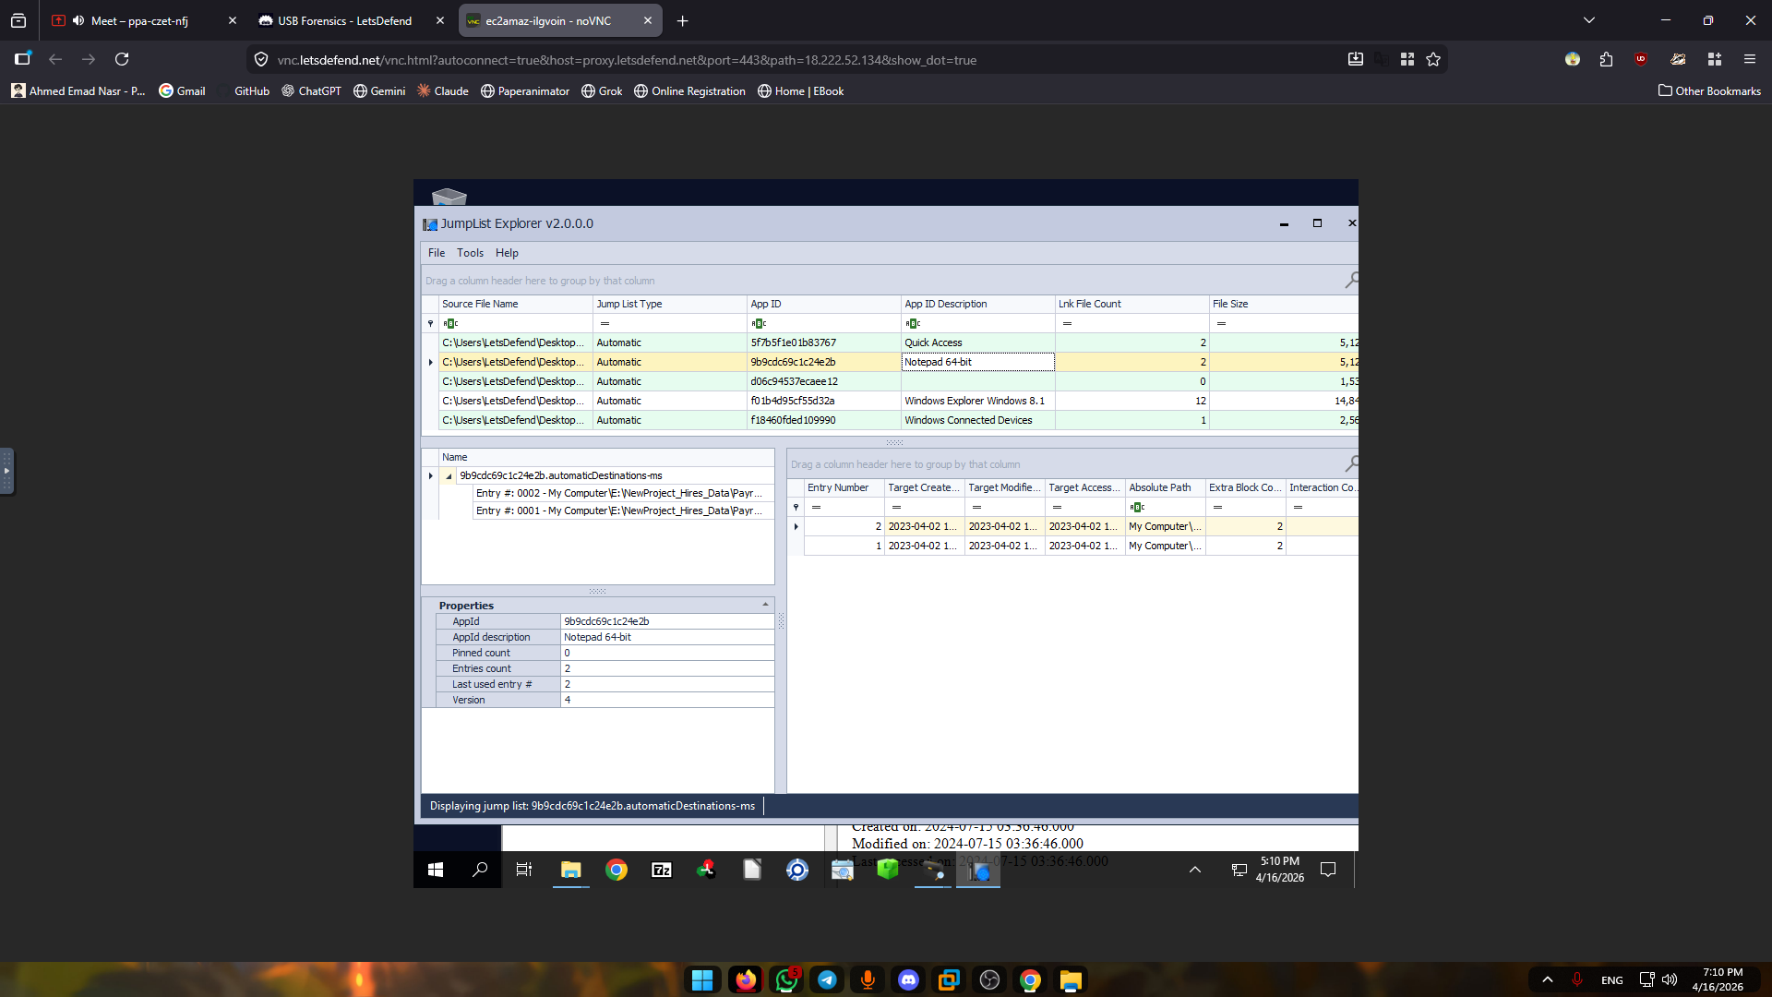

3.7 Full File Path of Exfiltrated Data
E:\NewProject_Hires_Data\Payroll_NewHires\Payroll_NewHires\Payroll_data1\Employee_PII.csv
Analysis:
The deeply nested directory structure suggests an attempt to obscure sensitive data within multiple layers, reinforcing the likelihood of intentional concealment.
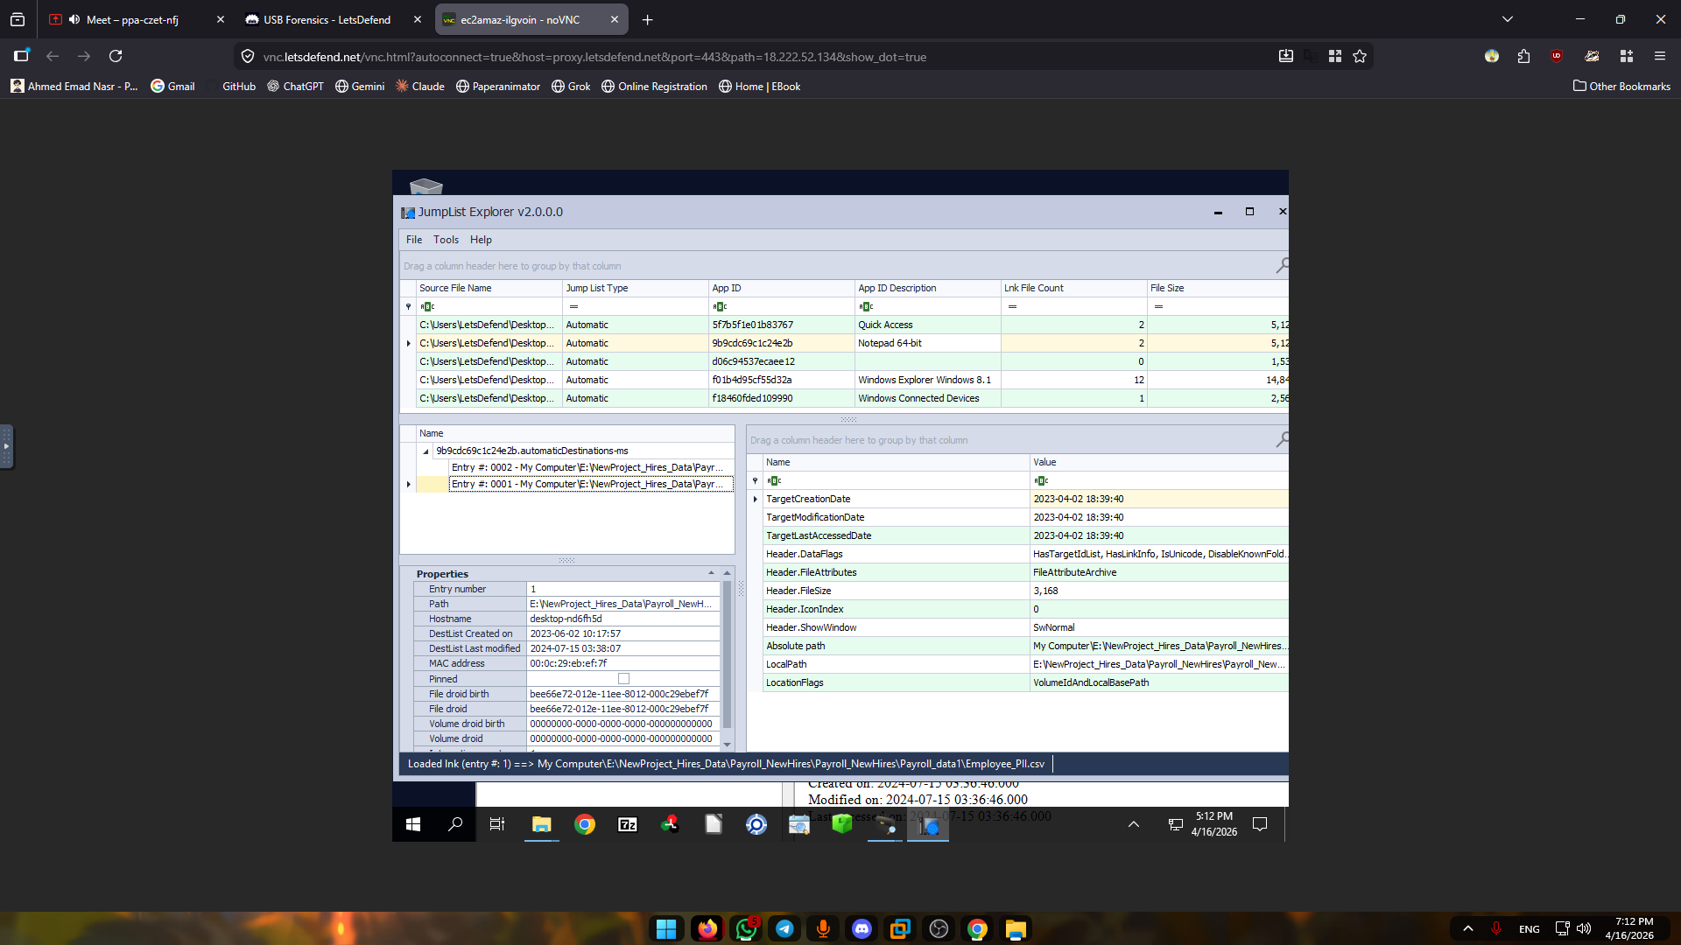

3.8 File Access Timestamp
- Timestamp: 2024-07-15 03:38:07
- Artifact: JumpList DestList
Analysis:
The DestList metadata provides precise evidence of when the file was accessed by the user via the associated application.
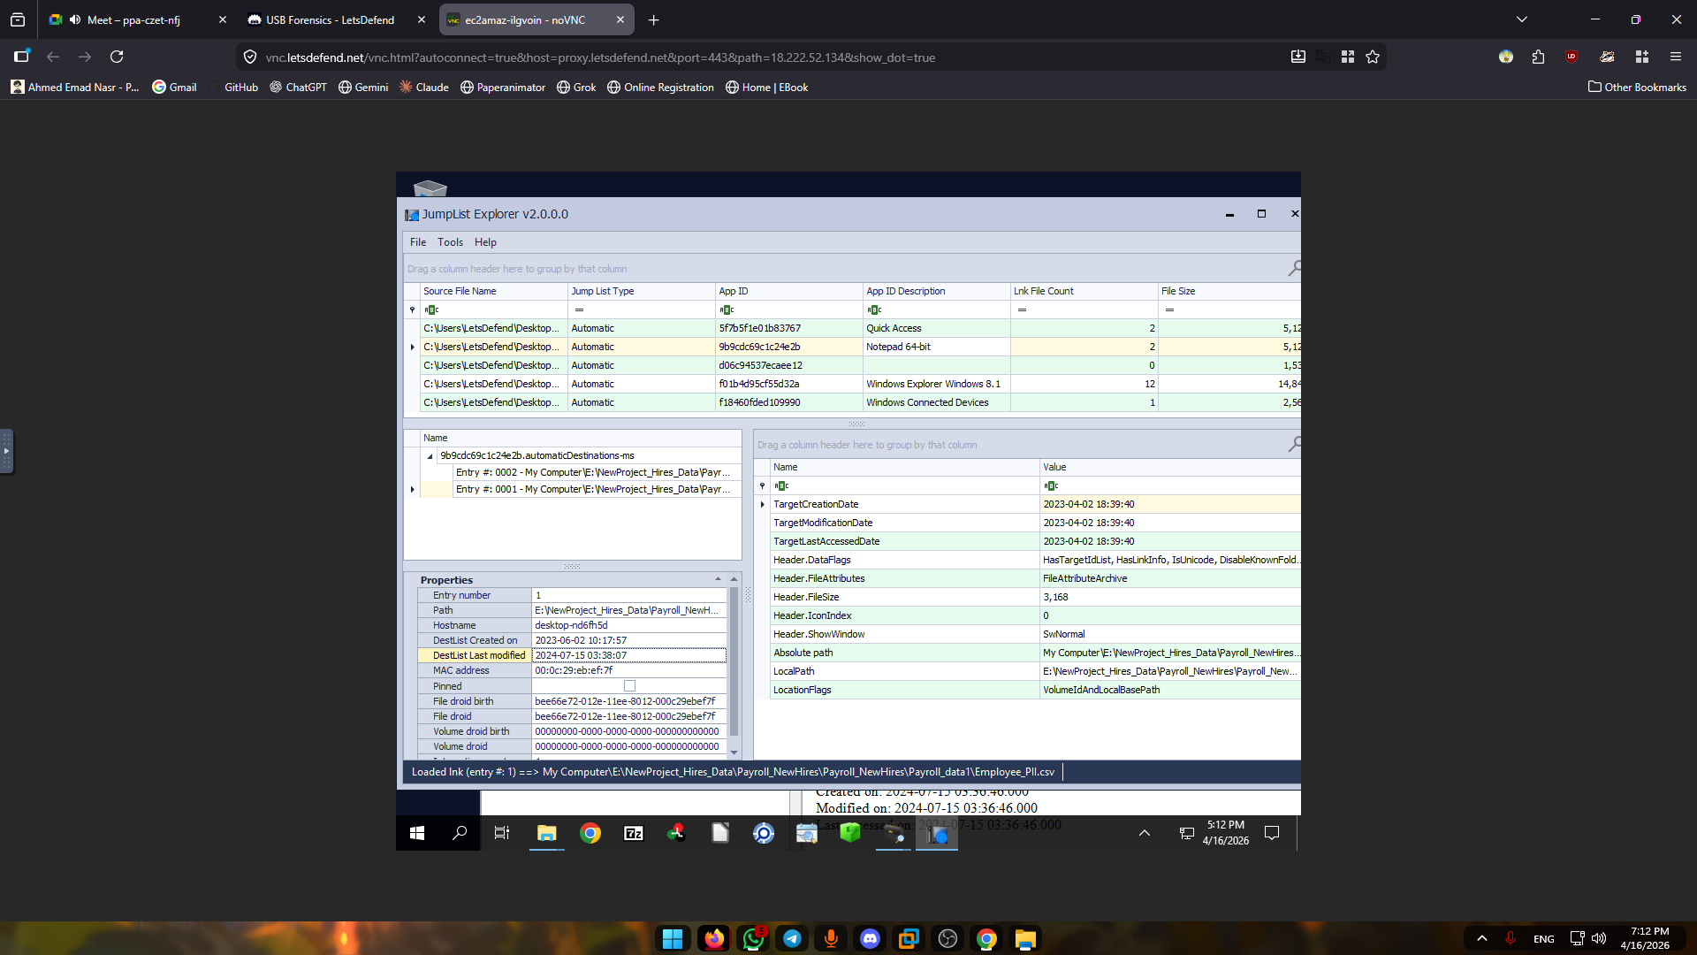

4. Attack Timeline
Timestamp | Phase | Description
03:36:22 | Initial Access | USB device connected and mounted
03:37:28 | Discovery | User browsed USB root directory
03:37:54 | Navigation | User traversed staging folders
03:38:07 | Collection | Sensitive CSV file accessed

5. Impact Assessment
- Confirmed exposure of Personally Identifiable Information (PII)
- Potential regulatory implications, including:
  - GDPR (General Data Protection Regulation)
  - CCPA (California Consumer Privacy Act)
Risk Implications:
- Identity theft
- Financial fraud
- Organizational reputational damage
- Legal and compliance exposure

6. Root Cause Analysis
The investigation identified multiple control failures that enabled the incident:
- Absence of USB device control policies
- Lack of Data Loss Prevention (DLP) mechanisms
- No monitoring or alerting on sensitive file access
- Insufficient endpoint visibility and detection capabilities
Conclusion:
The incident was enabled by inadequate endpoint security controls and lack of insider threat monitoring.

7. Recommendations
7.1 Data Loss Prevention (DLP)
Deploy DLP solutions to detect and prevent unauthorized transfer of sensitive data to removable media.

7.2 USB Device Control
- Disable USB mass storage devices by default
- Enforce strict whitelisting based on device identifiers (VID, PID, Serial Number)

7.3 Endpoint Detection & Response (EDR)
Enhance detection capabilities to identify:
- Access to sensitive files
- Abnormal use of removable media
- Suspicious file access patterns

7.4 User and Entity Behavior Analytics (UEBA)
Implement behavioral analytics to detect insider threats based on anomalous activity patterns.

7.5 Encryption Enforcement
Restrict usage to organization-approved encrypted USB devices only.

8. Conclusion
The forensic evidence conclusively demonstrates a malicious insider-driven data exfiltration incident using a removable USB device.
The speed of execution, structured file organization, and targeted file access confirm that the activity was deliberate and pre-planned.
Immediate implementation of endpoint security controls, monitoring mechanisms, and data protection policies is critical to prevent recurrence.







